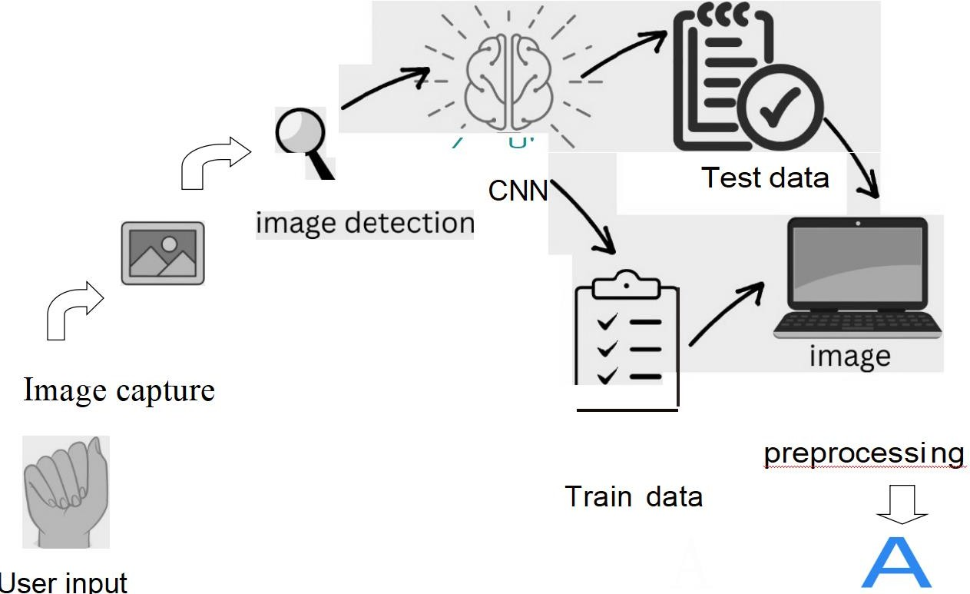
Project Design Phase-I Solution Architecture

Date | 07 NOVEMBER 2022
Team ID | PNT2022TMID12678
Project Name | Project – Real-time communication system  powered by AI for specially abled
Maximum Marks | 4 Marks

Solution Architecture Diagram:

